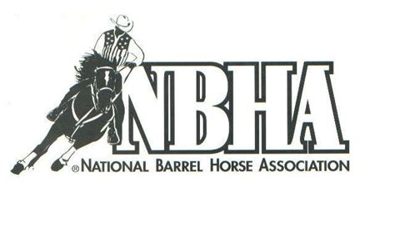

**NBHA IN02 DISTRICT SPONSORSHIP**

Thank you for considering being a sponsor of NBHA District 2. Our organization is open to any age exhibitor from youth to seniors! District 2 includes the following central Indiana counties: Benton, Warren, Fountain, Tippecanoe, Montgomery, Carroll, Clinton, Boone, Hendricks, Howard, Tipton, Hamilton, Marion, Grant, Madison, Hancock, Delaware, Henry, Randolph, and Wayne counties.

Your sponsorship will help support our annual district show which is held at the Tipton county fairgrounds on June 9-11. All the money made from this show goes towards awards at the end of the year for IN 02.

**DISTRICT BELT BUCKLE SPONSOR: $500~$300**

1. $500 will pay for the 4 Champion Open Belt Buckles at the end of the season. $300 will pay for the

3 buckles in either the Youth or the Senior at the end of the season.

2. Logo on district page website.

3. Name will be announced throughout the District show on June 9-11th.

4. If you provide a banner it will be used at the annual District show and the State show.

**BARREL SPONSOR: $250**

1. Barrel decal used at district show.

2. Logo on district page of website.

3. Name will be announced throughout the District show on June 9-11th.

4. If you provide a banner it will be used at the annual district show and the state show.

**WEBSITE SPONSOR: $100**

1. Logo on district page of website.

2. Name will be announced throughout the District show on June 9-11th.

3. If you provide a banner it will be used at the annual District show and the state show.

**SHOW SPONSOR: $50**

1. Name announced during the District show on June 9-11th.

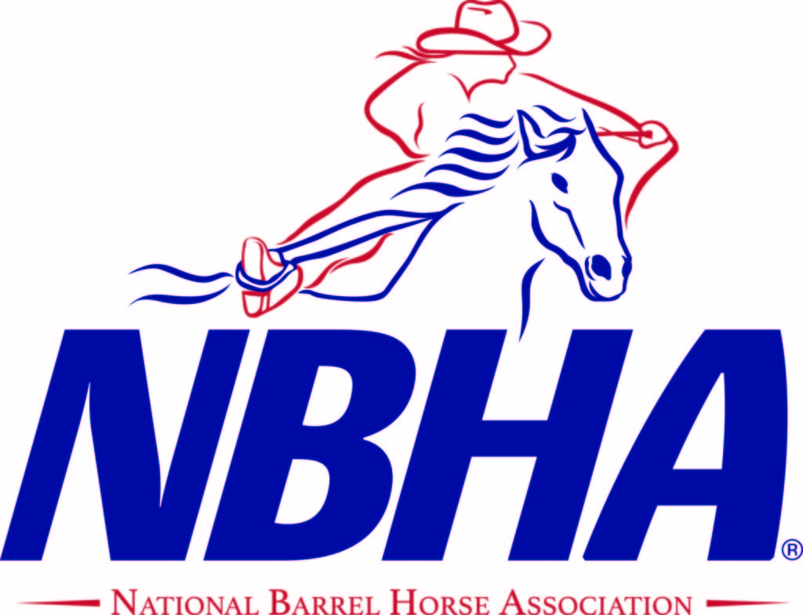

The sponsorships that we receive help buy awesome awards and help with the added money at our annual show. We are a family organization and would love to have you join us and help make our 2023 show season better than ever.

Sponsor Name__________________________________________________________

Address________________________________________________________________

Phone #________________________________________________________________

E-mail_________________________________________________________________

**Sponsorships due by June 1st**

Email camera/print ready logo to Indiana.NBHA.02@gmail.com

Make checks payable to: NBHA IN02 and mail to:

Angie Cunningham

2398 S 1150 W

Kempton, IN 46049-9213

any questions call or text Angie (765) 863-5409 or Kayla (765) 863-1695